**Project # 3 Team Sexy StingRays:** Daniel Byrne, Erin Cullen, Steven Orn, Vilma Santos, Jack Bolotin, Beverly Lau

**Project Title:**  Residential Property Value Predictor

**Project Scope & Objective:**

* Deciding at what price to buy or sell a residential property can be very daunting.
* Our team would like to provide a simple tool in where using publicly available data, we’ll provide our website user with an estimate fair market price for a particular property in Chicago.

**Project Description:**

* Data Aggregation Plan: Use historical real estate data to create one database using APIs, JS, and SQL
  + Link/Source: Realtor.com ….. https://www.realtor.com/
* Data Organization: Access, clean and organize data using Python, MySQL Database
* Create website and visualize data using Python, Pandas, Flask/Django, HTMS/CSS/Bootstap, Amazon AWS, and Tableau

**Project Inspirations:**

* Ways to present real estate data for City of Chicago
  + https://www.housingstudies.org/news/blog/exploring-property-sales-data-ihs-data-portal/
* Ways to present real estate trends
  + https://www.zillow.com/homes/for_sale/113952283_zpid/41.94557,-87.639713,41.942909,-87.644519_rect/17_zm/1_fr/

**Proposed Project Elements:**

* Home / Index will display map and trendline
* Interactive site will allow a user to select property variables from the dropdown boxes, e.g. no of bedrooms, etc.
* Predicted price would be displayed in a field next to the dropdown boxes.

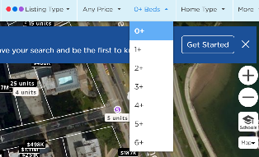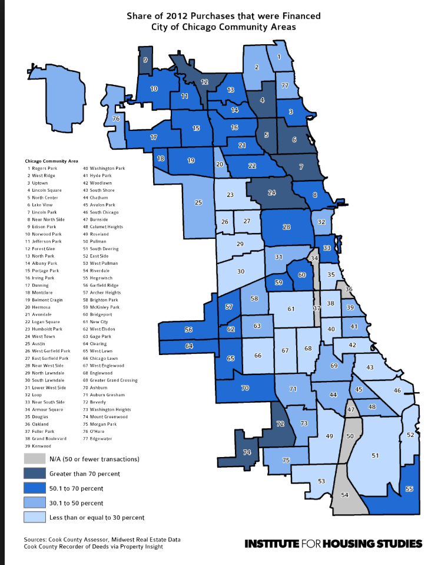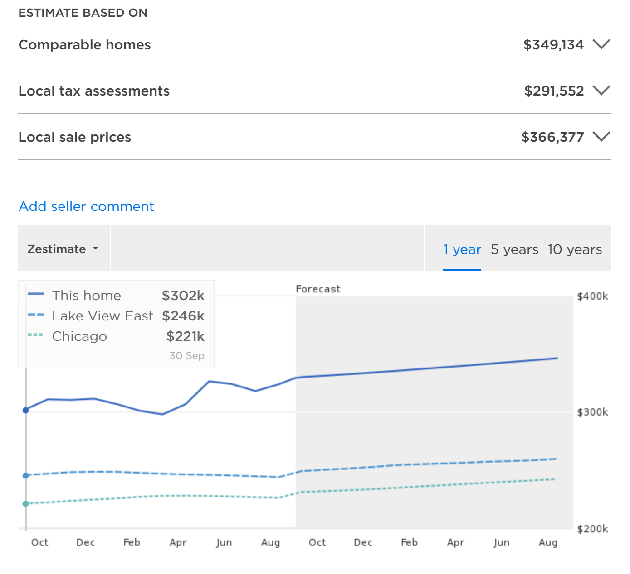

**Project Repository:**

* Link to Git: https://github.com/Vilma0228/Project3-Machine-Learning